**Customer relations, not brand power, are the most important brand asset**

*Ten years ago brand value was the single most important asset businesses used when deciding whether to acquire a UK company but its significance has decreased as the shift to digital marketing and the increasing use of personalised communication makes a brand less important than its customer base.*

By Sarah Vizard, 4 Mar 2016

[*https://www.marketingweek.com/brand-power-loses-out-as-customer-relations-gain-importance/*](https://www.marketingweek.com/brand-power-loses-out-as-customer-relations-gain-importance/)

An analysis of British brands bought between 2005 and 2014 by Markables found that while the proportion of a transaction attributed to brand value was 25% in 2005 this had decreased to just 13% in 2014. Over the same period the value of customer relations increased from 12% to 24%, overtaking the role of brands in acquisitions.

The move reflects a shift in marketing strategy that has seen businesses move more towards CRM and personalised messages and away from more traditional mass media. The latest figures from the AA/Warc expenditure report estimates that total UK ad spend was up by 6.1 % in 2015. In comparison, digital saw growth of 13.5%, boosting its market share.

While TV also saw its growth outpace the wider market, other sectors including radio, out of home, print and cinema all failed to keep up and lost market share.

“Bolstered by the digital age and CRM, businesses shifted their marketing strategies much more towards direct relations and interactions with their customers, away from traditional mass media,” says Christof Binder, managing partner at Markables.

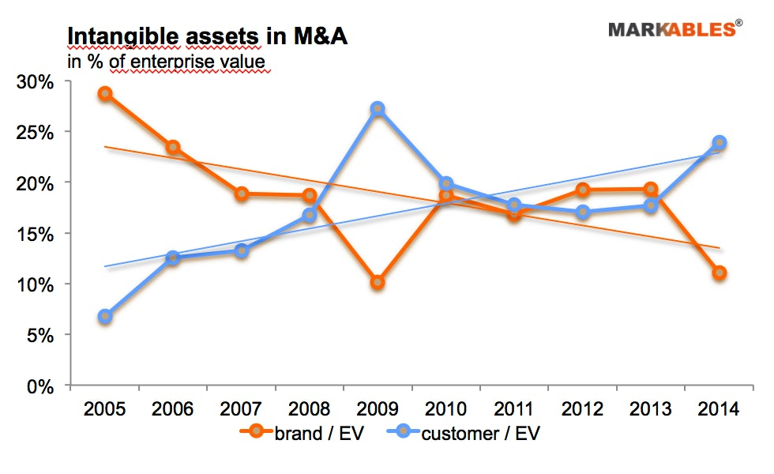

“Digital has changed the media landscape, allocation of marketing budgets, campaign creation and content, media planning, performance monitoring and the way marketing and brand management functions are organised.”

**Branding loses dominance**

This shift has impacted the importance of brands. Where once it was vital brands had a strong identity to be able to reach anonymous customers, now it is more important to know customers individually and tailor communications to them.

While branding still remains important, it has lost its dominance claims the AA/Warc expenditure report. And for M&A investors in particular the focus has shifted from brands to customer relations.

“[M&A investors] are now willing to pay more for customer relations than they pay for brands, for a simple reason – their superior potential to create additional value from the combination of two businesses. Once the customer is known in person, it is easy to sell additional products to them. In contrast, the creation of additional value from brands is far more difficult,” says Binder.

“As a result, corporate investors effectively spend significantly less to acquire brands than they did 10 years ago.

____________________________________________________________________________

“**It has become a reality that [investors] no longer acquire businesses for their brands but for their true direct customer relations**.” Christof Binder, managing partner, Markables

As a percentage of all acquisitions, brand-centric businesses accounted for less than 10% in 2014 from almost 30% in 2005. By comparison customer-centric businesses have seen their percentage of acquisitions increase from around 7% in 2005 to 20% in 2014. Brand-centric businesses typically include food and beverage brands, retailers, fashion brands and restaurants.

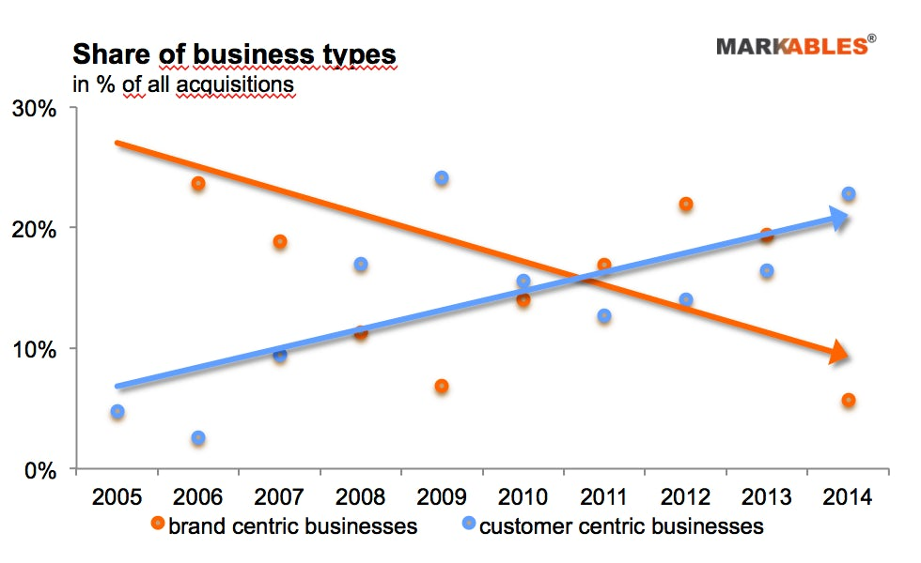

**What brands should do**

The decreasing importance of brand value in M&A is not just specific to the UK. Similar impacts have been found in the US and Australia. However, the impact has been more widely felt in the UK due to the strength of its retail sector and the success of own label products.

The major supermarkets as well as Marks & Spencer and Boots have all looked to boost their profitability through private label products. But this success has led to a weakening in the power of wholesale brands.

“Instead of pursuing offensive marketing strategies, most wholesale brands have been stuck in a mature market between powerful retailers and the digitalisation of consumer behaviour,” says Binder.

One answer for brand owners is to find their own ways to communicate directly with consumers. FMCG brands including Unilever, Procter & Gamble and Pernod Ricard are all upping their focus on ecommerce so they can build a relationship and ultimately sell directly to customers.

Brands should also focus more on ‘Britishness’, says Binder. He concludes: “Britishness is an attribute which is attractive to consumers all over the world, in many different categories. The world loves Britishness in all its different aspects provided it is authentic. Brand Britain should capitalise on Britishness itself instead of divesting it to foreigners.”